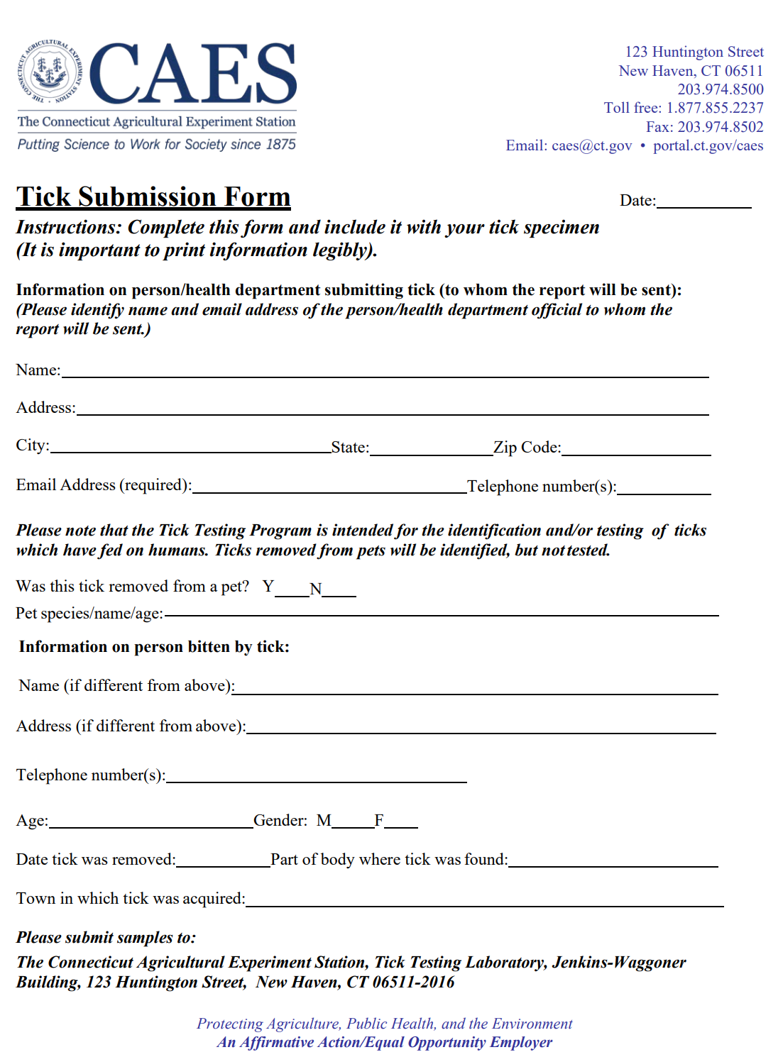
Jennifer Zbell, MPH, RS- Director of Health DOH@RidgefieldCT.gov
Ridgefield Health Department
Specimen Name:

